Q1)
The appropriate mix is a cut in interest rate (shift the LM curve down) and a fiscal contraction (shift the IS curve to the left).
With lower domestic interest rate, domestic bonds become less attractive due to their reduced returns. Investors are likely to sell these bonds in favor of foreign bonds, leading to an increase in demand for foreign currency. As a result, domestic currency depreciates, making exports relatively cheaper and imports more expensive. Consequently, exports rise while imports fall, resulting in an increase in net exports. Additionally, lower interest rate encourages more investment, leading to overall higher output. Reduction in fiscal spending can help balance the economy and maintain output at its natural level.
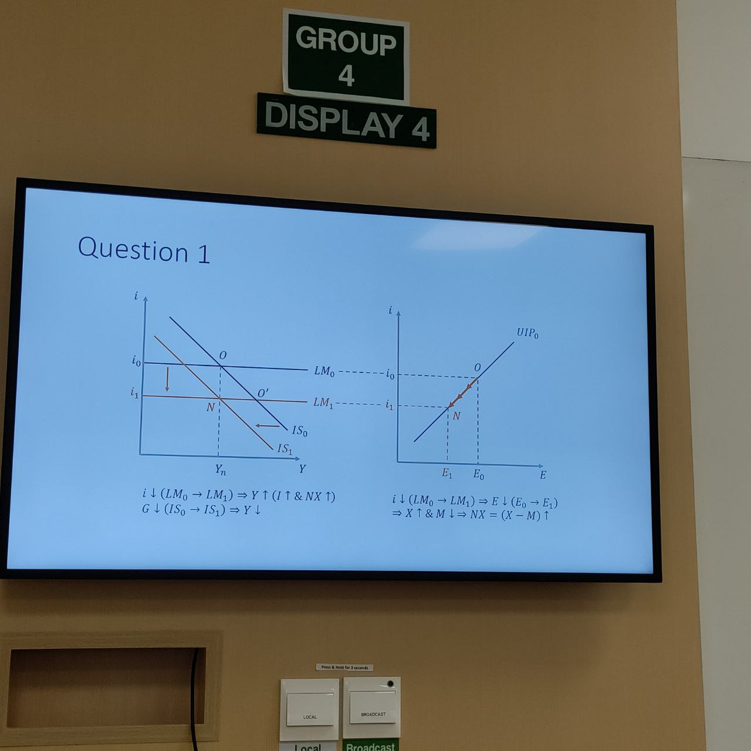

Q2)
a)
Expansionary monetary policy stimulates the economy and boosts output. Consumption increases because output increases. Investment increases because output increases and interest rate falls.

b)
Domestic currency depreciation leads to higher exports and lower imports at a given income level. However, as output increases, imports will also rise. While we would generally expect net exports to improve, there are situations where net exports could fall if the marginal propensity to import is significantly large.
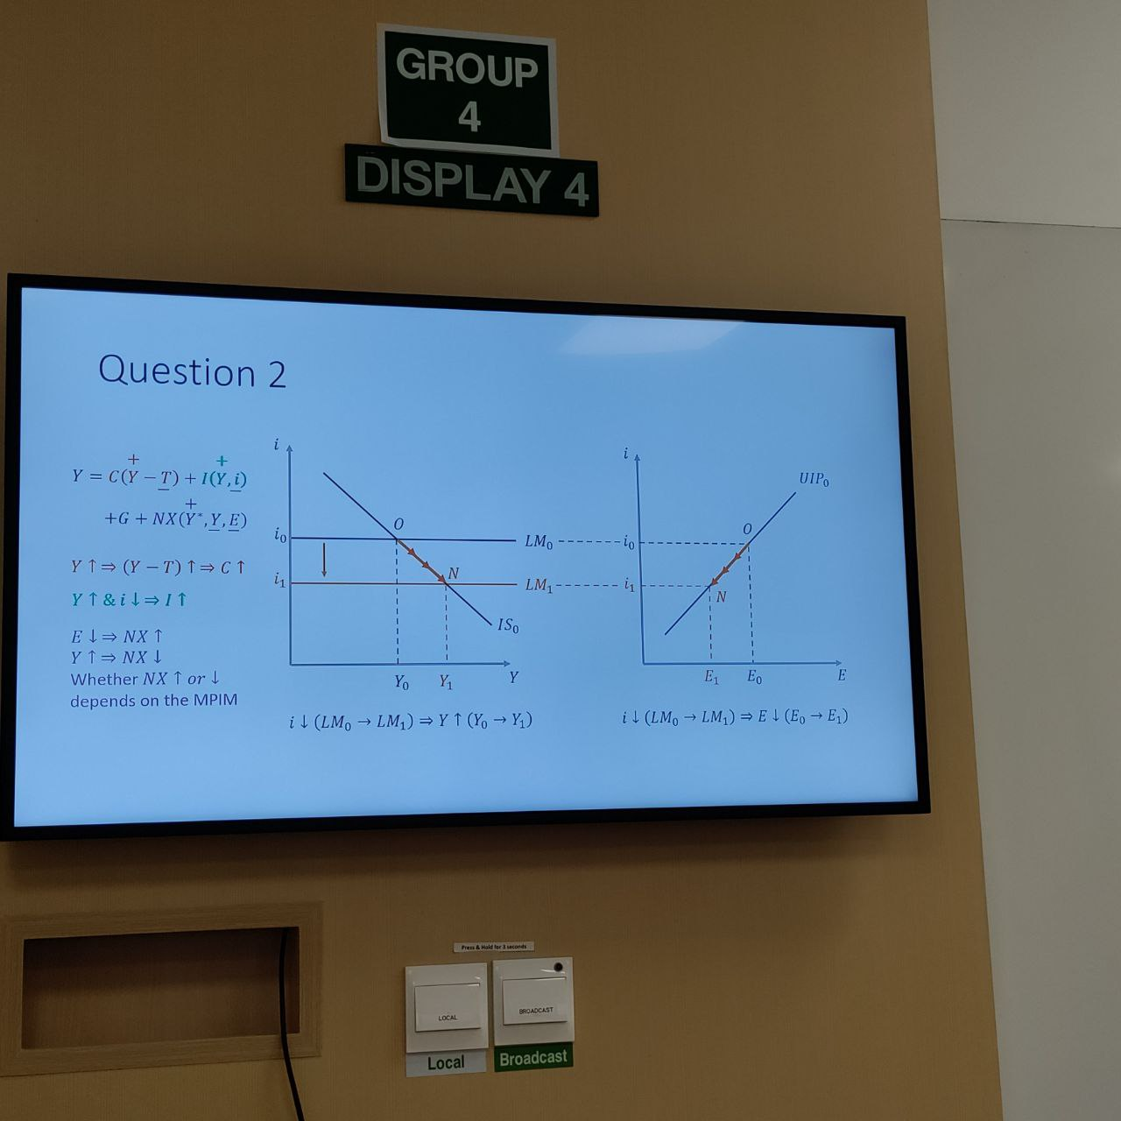
Q3)
a)
The increase in foreign output directly raises foreign demand for domestic goods, resulting in increased exports.
Higher foreign interest rate makes foreign bonds more attractive compared to domestic bonds, increasing demand for foreign currency and causing the domestic currency to depreciate. This depreciation further improves exports and reduces imports. As a result, the UIP curve shifts to the left because given the same domestic interest rate, the exchange rate is lower.
Both effects increase net exports and domestic output. Hence, the IS curve shifts to the right, reflecting higher domestic output at the same level of domestic interest rate.
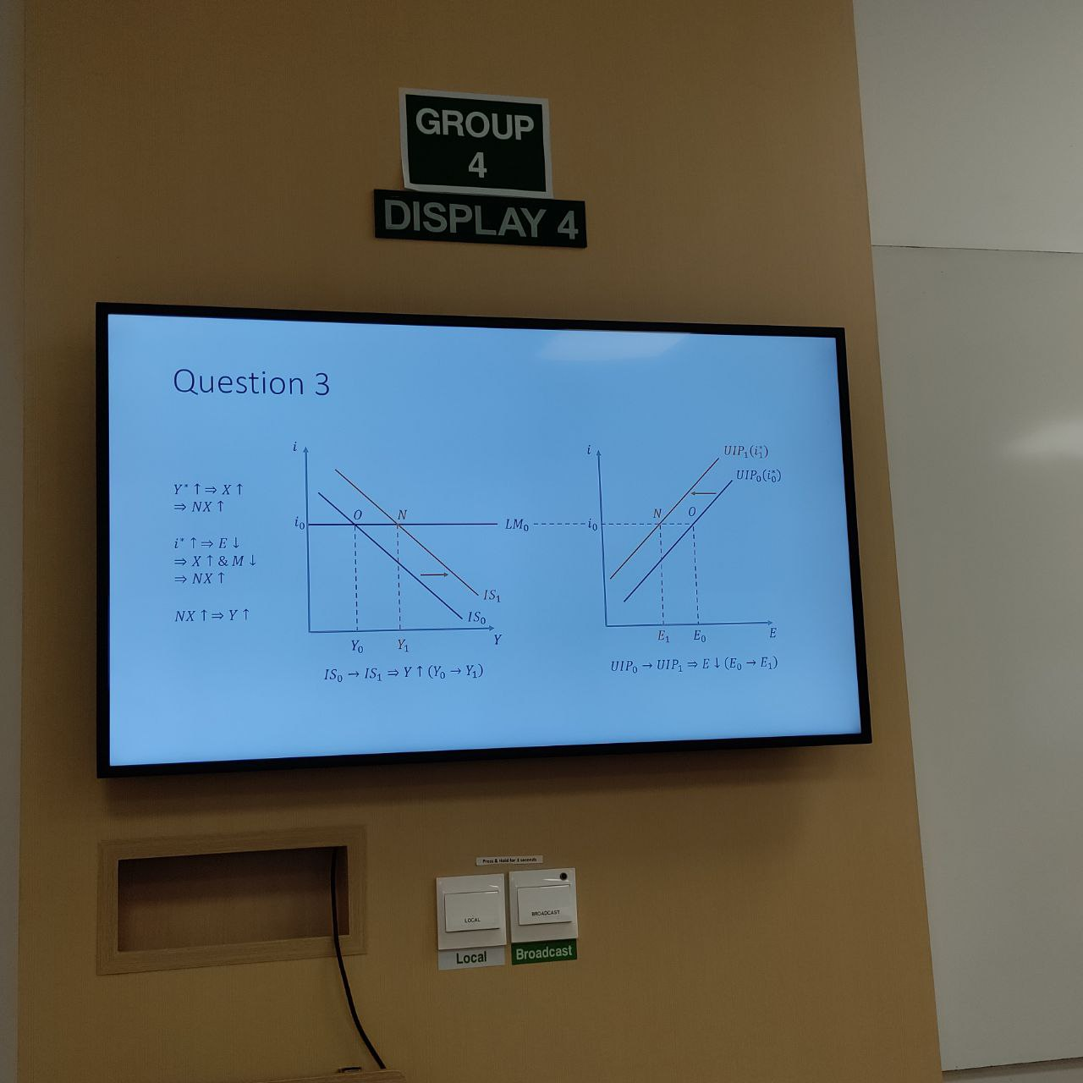

b)
If the central bank raises domestic interest rate to match the increase in the foreign interest rate, the exchange rate will remain unchanged. The UIP curve still shifts to the left because given the same domestic interest rate, the exchange rate is lower. But the IM curve will shift up due to the rise in domestic interest rate.
The direct effect of higher foreign output on net exports still applies, so the IS curve still shift to the right. However, the increase in domestic interest rate reduces investment and lower output. It is unclear whether domestic output will ultimately rise or fall.

c)
The analysis in part (b) indicates that the central bank can decrease domestic output by raising domestic interest rate. Take the case of i₁ = i=* for example. If the combined effects of increased Y* and higher interest rates (both I and i*) still lead to an overall increase in domestic output, the central bank will need to raise rate further. Conversely, if these combined effects result in a decrease in domestic output, the central bank should increase domestic interest rates by a smaller amount (i<i₁*).
This policy may be necessary when the domestic output is initially at its natural level (potential output). In this case, the increases in Y* and i* will push the domestic output above the natural level, causing worries about inflation.

